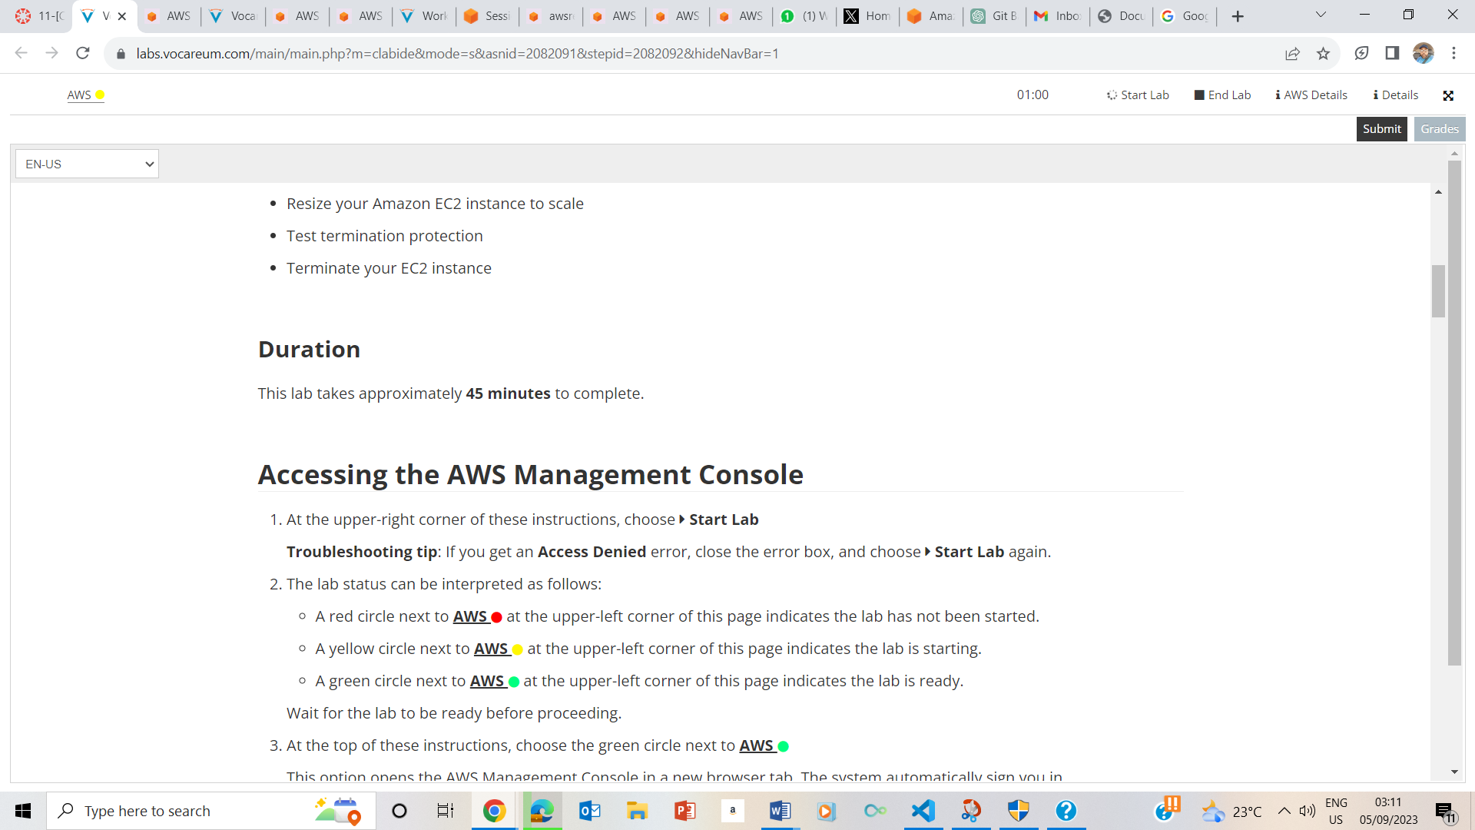

ACCESSING AWS MANAGEMENT CONSOLE PENDING

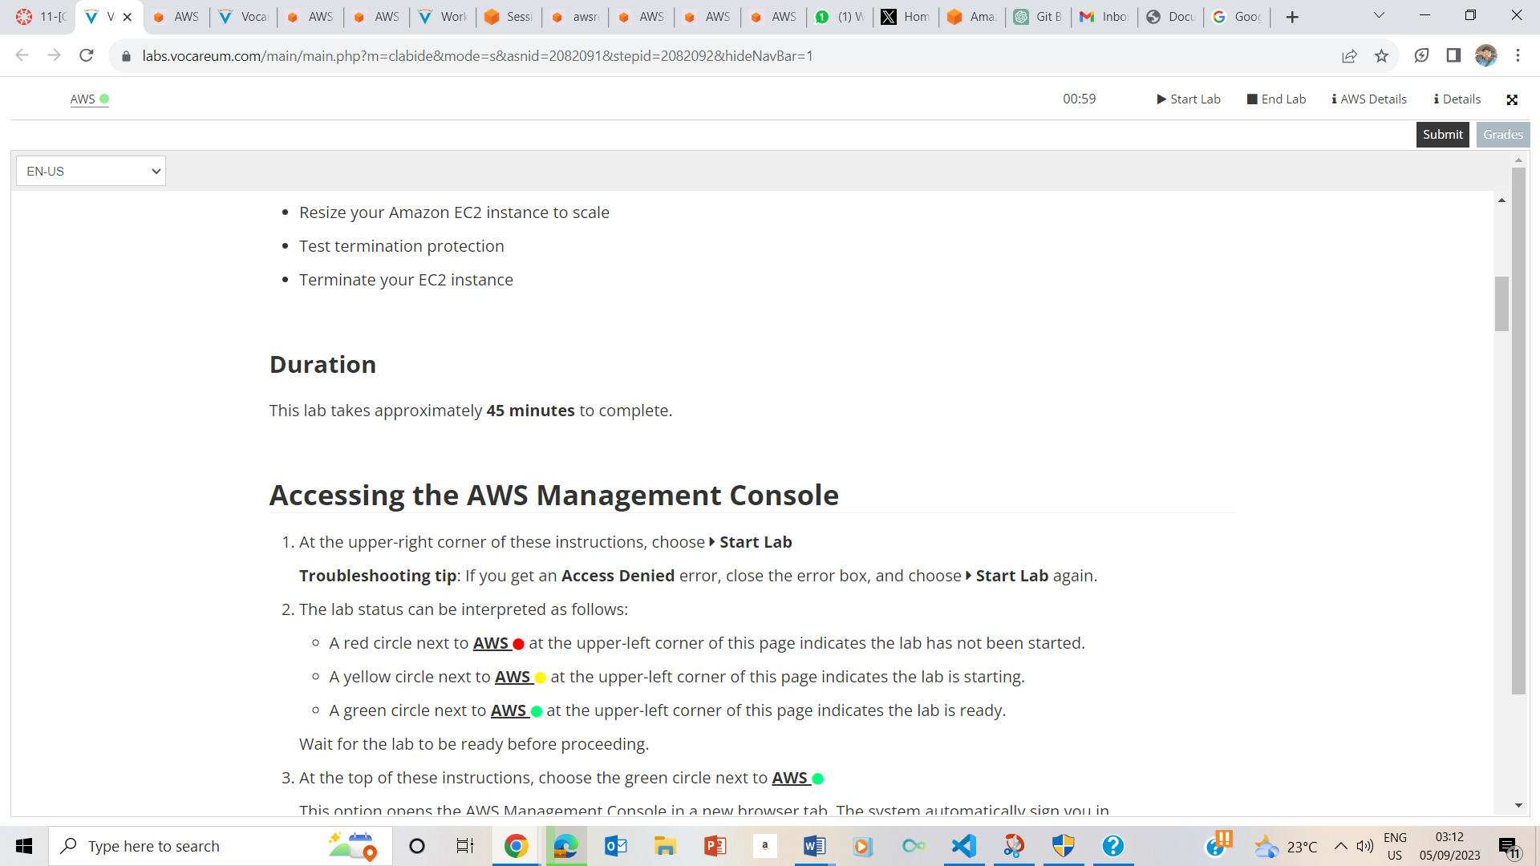

ASSESSING AW

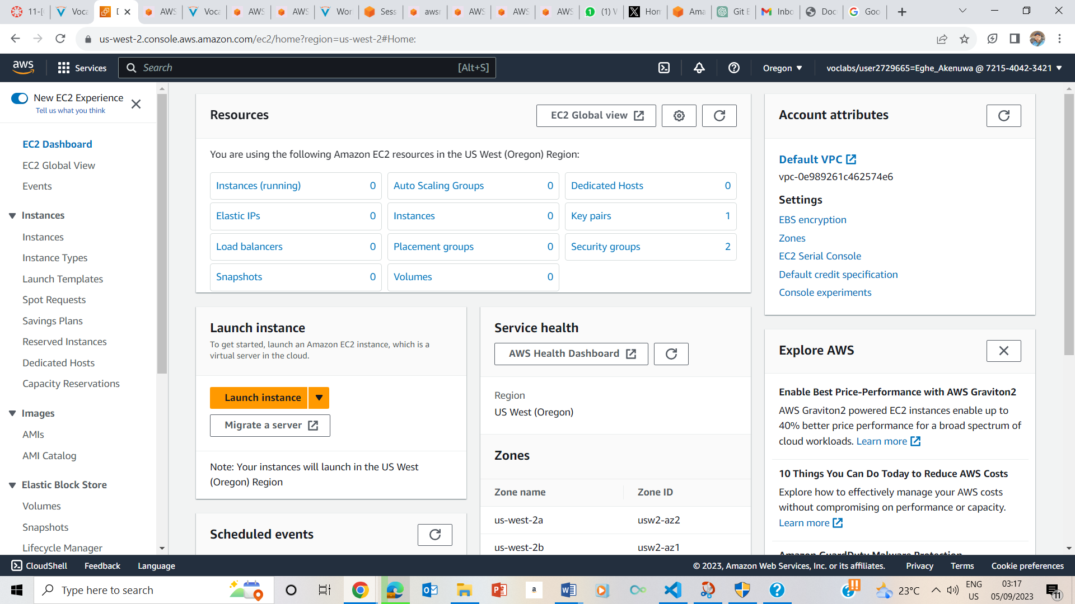

EC2 INSTANCE LAUNCHING

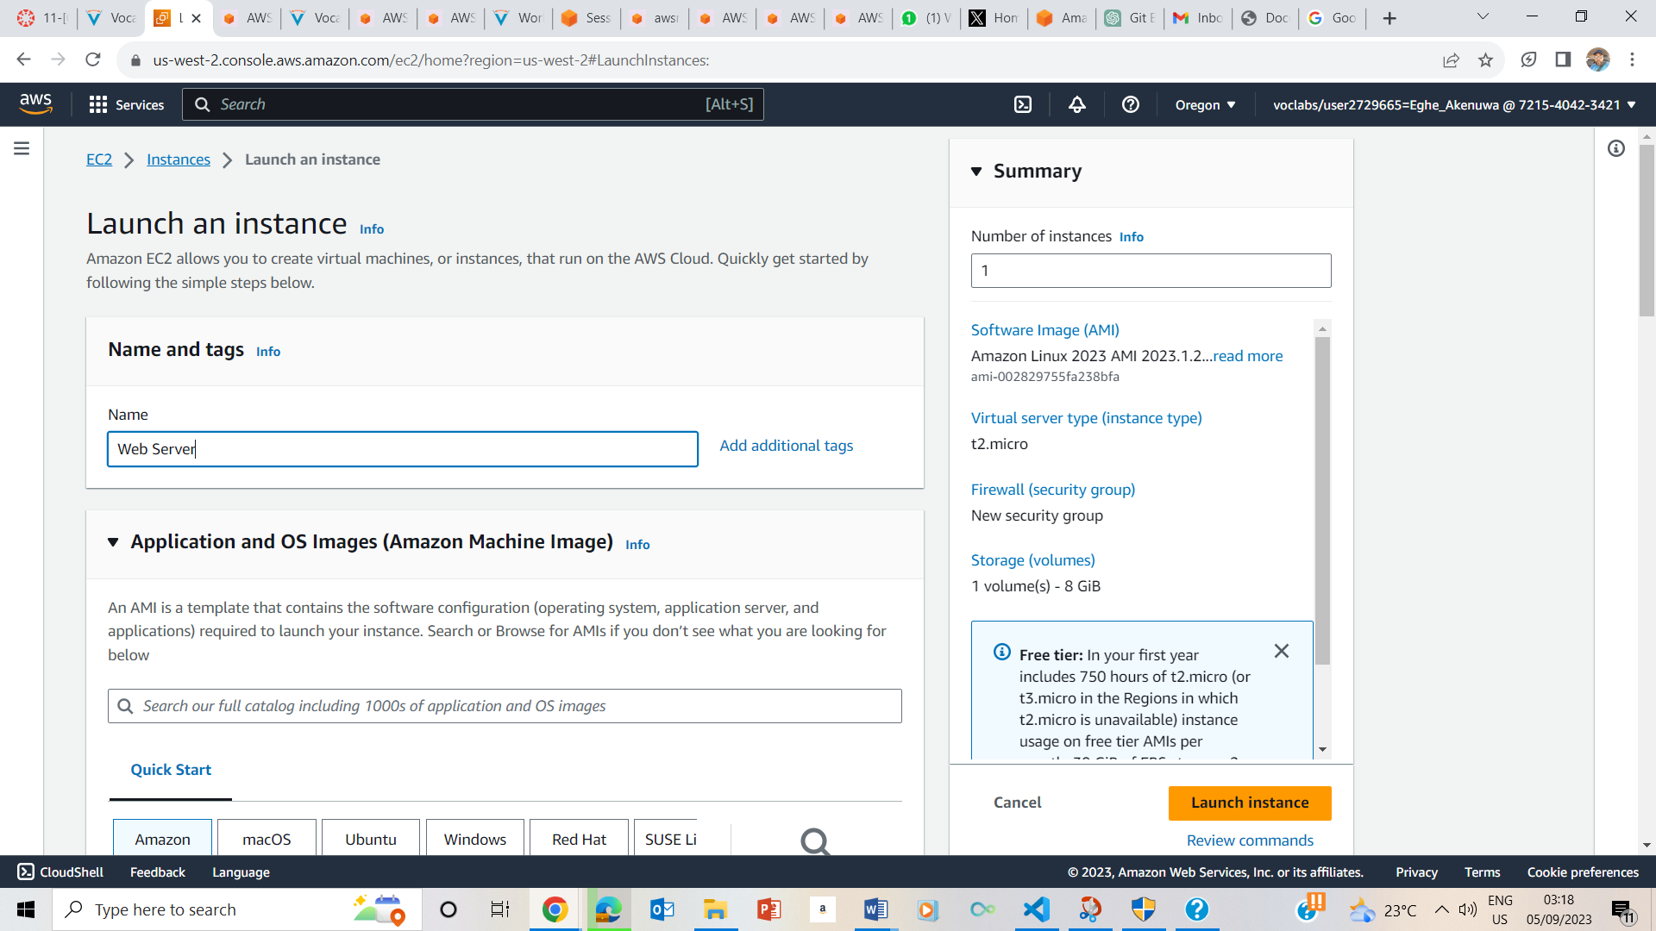

**STEP 1 – LAUCHING EC2 INSTANCE**

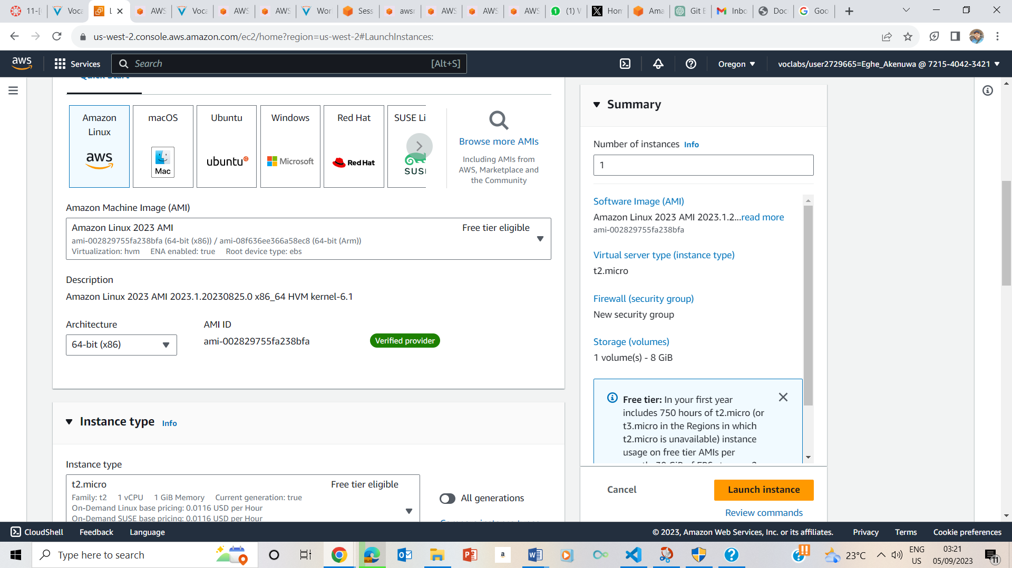

**Step 2: Choosing an Amazon Machine Image (AMI)**

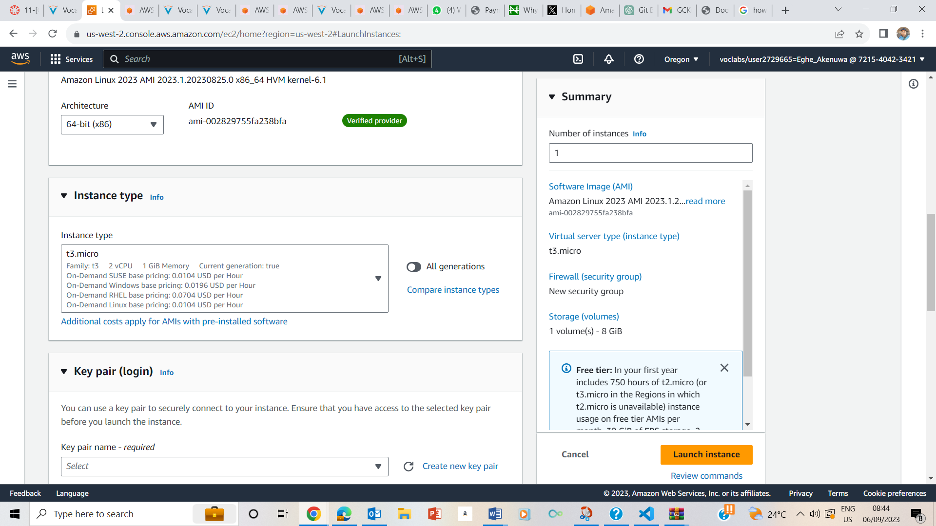

### Step 3: Choosing an instance type – t3.micro

### 

### Step 4: Configuring a key pair- Proceed without a key pair (Recommended instruction).

### 

### Step 5: Configuring the network settings

### 

### Step 6: Adding storage (Kept the default storage configuration)

### 

### Enabled Termination Protection

### 

The script does the following:

* Install an Apache web server (httpd)
* Configure the web server to automatically start on boot
* Activate the Web server
* Create a simple web page

### Step 7: Configuring advanced details

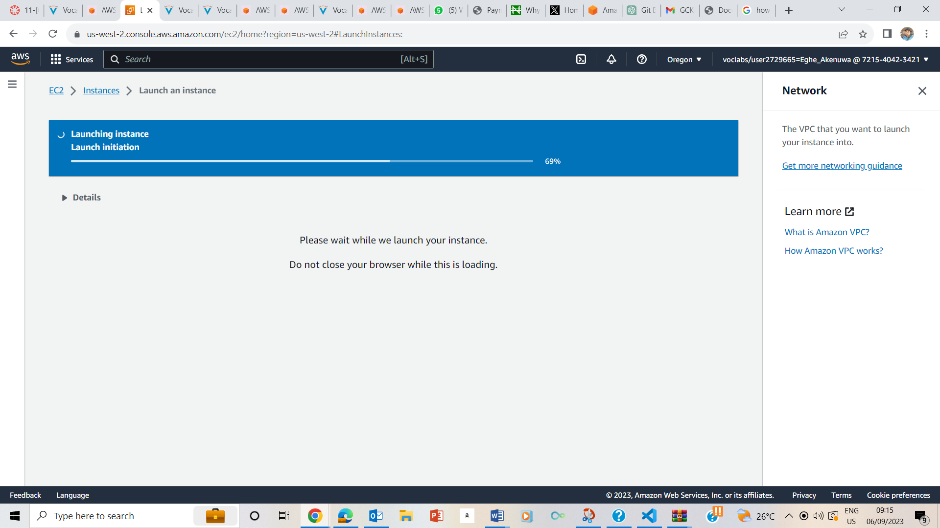

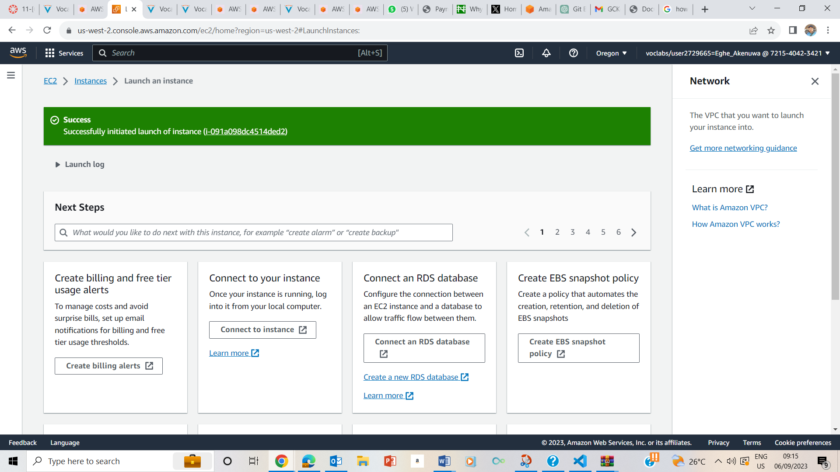

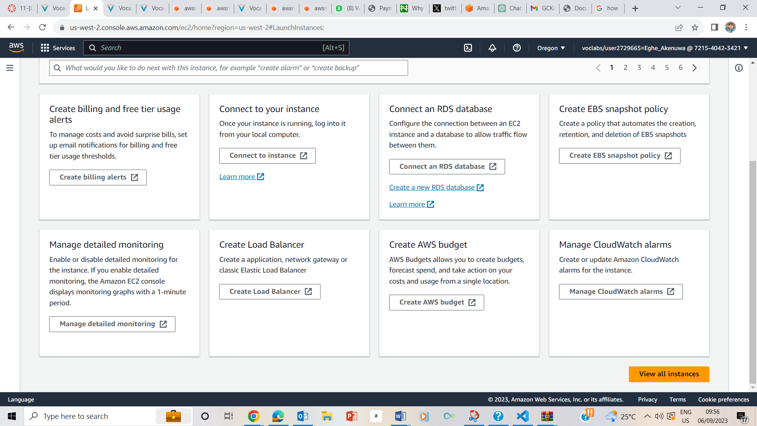

View all instances

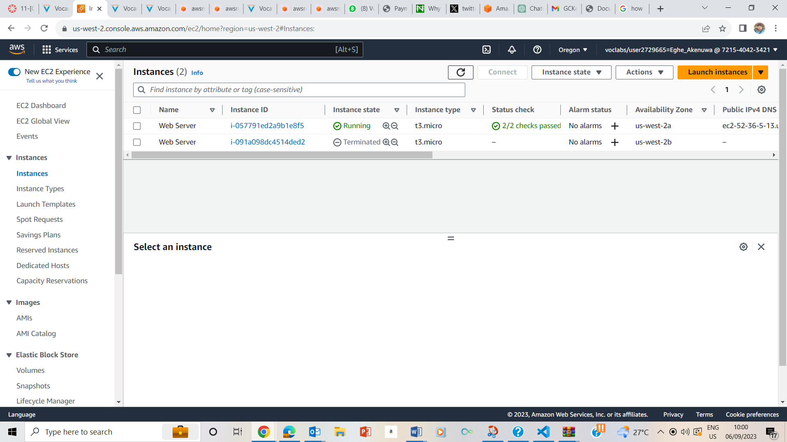

### Step 8: Launching an EC2 instance: showing Instance State – Running and Status Check- 2/2 checks passed.

## Task 2: Monitor Your Instance

### 